Reading data from database table

Model manager provides various methods to read data from database table.

- get()
- all()
- filter()
- values()
- exclude()
- aggregate()
- first()
- last()
- order_by()

get()
model manager provides a method called get()
This method is used to read single record (model instance)
It will try to read based on condition.

Syntax: model-name.objects.get(condition)

In application development always use get method to read single record using primary key column.
Get method raises error if returns more than one record.
Get method of model manager returns model instance.

PS D:\Backup\Django9amMar\project10> python manage.py shell
13 objects imported automatically (use -v 2 for details).

Ctrl click to launch VS Code Native REPL
Python 3.12.10 (tags/v3.12.10:0cc8128, Apr 8 2025, 12:21:36) [MSC v.1943 64 bit (AMD64)] on win32
Type "help", "copyright", "credits" or "license" for more information.
(InteractiveConsole)
>>> from app1.models import Student
>>> stud1=Student.objects.get(rollno=1)
>>> print(stud1)
Student object (1)
>>> print(stud1.rollno,stud1.name,stud1.course,stud1.fee)
1 naresh python 3000.0
>>> stud2=Student.objects.get(rollno=3)
>>> print(stud2)
Student object (3)
>>> print(stud2.rollno,stud2.name,stud2.course,stud2.fee)
3 kishore c++ 1000.0
>>> stud3=Student.objects.get(rollno=10)
Traceback (most recent call last):
File "<console>", line 1, in <module>
File "C:\Users\Satish Gupta\AppData\Local\Programs\Python\Python312\Lib\site-packages\django\db\models\manager.py", line 87, in manager_method
return getattr(self.get_queryset(), name)(*args, **kwargs)
^^^^^^^^^^^^^^^^^^^^^^^^^^^^^^^^^^^^^^^^^^^^^^^^^^^
File "C:\Users\Satish Gupta\AppData\Local\Programs\Python\Python312\Lib\site-packages\django\db\models\query.py", line 639, in get
raise self.model.DoesNotExist(
app1.models.Student.DoesNotExist: Student matching query does not exist.
>>> stud4=Student.objects.get(course='c++')
Traceback (most recent call last):
File "<console>", line 1, in <module>
File "C:\Users\Satish Gupta\AppData\Local\Programs\Python\Python312\Lib\site-packages\django\db\models\manager.py", line 87, in manager_method
return getattr(self.get_queryset(), name)(*args, **kwargs)
^^^^^^^^^^^^^^^^^^^^^^^^^^^^^^^^^^^^^^^^^^^^^^^^^^^
File "C:\Users\Satish Gupta\AppData\Local\Programs\Python\Python312\Lib\site-packages\django\db\models\query.py", line 642, in get
raise self.model.MultipleObjectsReturned(
app1.models.Student.MultipleObjectsReturned: get() returned more than one Student -- it returned 2!
>>> stud4=Student.objects.get(course='java')
>>> print(stud4)
Student object (2)
>>> print(stud4.rollno,stud4.name,stud4.course,stud4.fee)
2 suresh java 2000.0
>>>

Views.py
def get_one_stud(request,rno):
try:
stud=Student.objects.get(rollno=rno)
response=render(request,"studone_temp.html",context={'stud':stud})
return response
except Student.DoesNotExist:
response=render(request,"studone_temp.html",context={'msg':'Invalid Rollno'})
return response

def get_one_stud1(request):
try:
stud=Student.objects.get(rollno=int(request.GET.get('rno')))
response=render(request,"studone_temp.html",context={'stud':stud})
return response
except Student.DoesNotExist:
response=render(request,"studone_temp.html",context={'msg':'Invalid Rollno'})
return response
def getonehome(request):
response=render(request,"studonehome.html")
return response

urls.py

from django.contrib import admin
from django.urls import path
from app1.views import addstud_temp,addstudent_view
from app1.views import get_one_stud,get_one_stud1,getonehome
urlpatterns = [
path('admin/', admin.site.urls),
path("",addstud_temp),
path("addstudview/",addstudent_view),
path("getonestud/<int:rno>/",get_one_stud),
path('getonestud1/',get_one_stud1),
path('getonehome/',getonehome),

]

studone_temp.html
<!DOCTYPE html>
<html lang="en">
<head>
<meta charset="UTF-8">
<meta name="viewport" content="width=device-width, initial-scale=1.0">
<title>Document</title>
</head>
<body>
<table border="2" width="100%">
<tr>
<td>Rollno</td>
<td>{{stud.rollno}}</td>
</tr>
<tr>
<td>StudentName</td>
<td>{{stud.name}}</td>
</tr>
<tr>
<td>StudentCourse</td>
<td>{{stud.course}}</td>
</tr>
<tr>
<td>StudentFee</td>
<td>{{stud.fee}}</td>
</tr>
</table>
<h2>{{msg}}</h2>
</body>
</html>

Studonehome.html

<!DOCTYPE html>
<html lang="en">
<head>
<meta charset="UTF-8">
<meta name="viewport" content="width=device-width, initial-scale=1.0">
<title>Document</title>
</head>
<body>
<form action="/getonestud1" method="get">
<table border="2" width="100%">
<tr>
<td>StudentRollno</td>
<td><input type=text name="rno"></td>
</tr>
<tr>
<td><input type="submit" value="find"></td>
<td><input type="reset"></td>
</tr>

</table>
</form>
</body>
</html>

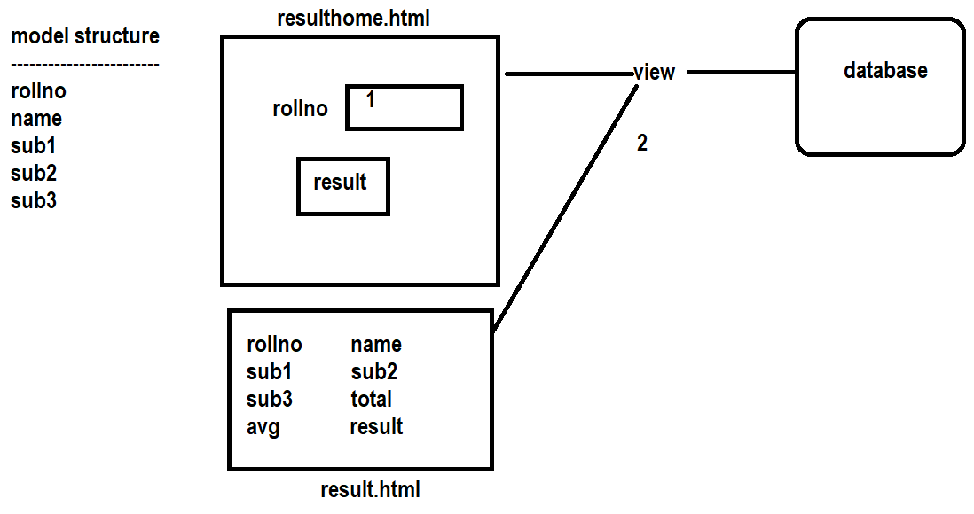

all() method of model manager

all method of model manager returns queryset.
queryset contains result of executed query(SELECT)

Syntax: model-name.objects.all()

>>> qs=Student.objects.all()
>>> print(type(qs))
<class 'django.db.models.query.QuerySet'>
>>>
>>> print(qs.query)
SELECT `app1_student`.`rollno`, `app1_student`.`name`, `app1_student`.`course`, `app1_student`.`fee` FROM `app1_student`
>>>

>>> print(qs)
<QuerySet [<Student: Student object (1)>, <Student: Student object (2)>, <Student: Student object (3)>, <Student: Student object (4)>, <Student: Student object (5)>]>
>>>
>>> for stud in qs:
... print(stud.rollno,stud.name,stud.course,stud.fee)
...
1 naresh python 3000.0
2 suresh java 2000.0
3 kishore c++ 1000.0
4 ramesh c++ 1500.0
5 kiran c 1000.0
>>>

Questset is collection of model instances and each model instance represents one row/record in database table.

filter()

